Wooden Dragon Medium

The year 2024 will be the year of the Wood Dragon, according to the Chinese zodiac. This is a rare and auspicious combination that only occurs once every 60 years. But what does it mean for you and your destiny?
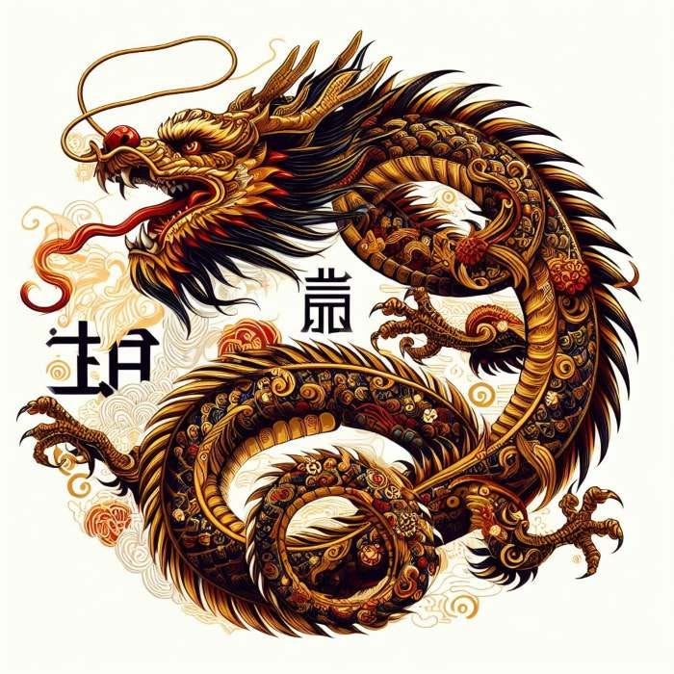

# The Dragon in the Chinese Zodiac
The Dragon is the fifth animal in the Chinese zodiac, and it represents power, courage, charisma, and innovation. The Dragon is a leader, a visionary, and a trailblazer. The Dragon is also ambitious, confident, and independent. The Dragon can achieve great things, but also face great challenges.

# The Wood Element in the Chinese Zodiac
The Wood element is one of the five elements that influence the personality and destiny of each animal sign. The Wood element represents growth, flexibility, creativity, and generosity. The Wood element also symbolizes spring, the season of renewal and rebirth.

# The Wood Dragon Personality
The combination of Wood and Dragon creates a dynamic and energetic personality that is always ready for action and adventure. Wood Dragons are optimistic, enthusiastic, and adaptable. They are not afraid of change or challenge. They are also creative, innovative, and original. They have a lot of ideas and visions that they want to share with the world.
Wood Dragons are also generous, compassionate, and altruistic. They care about others and want to make a positive difference in the world. They are not selfish or greedy. They are willing to share their resources and talents with those in need.

# The Wood Dragon Challenges
However, Wood Dragons are not perfect. They also have some weaknesses and challenges that they need to overcome. Wood Dragons can be impulsive, restless, and impatient. They can act without thinking or planning ahead. They can also be overconfident, arrogant, and stubborn. They can have a hard time admitting their mistakes or accepting criticism.
Wood Dragons can also be too idealistic, unrealistic, and naive. They can have high expectations of themselves and others that are hard to meet. They can also be easily disappointed or disillusioned when things don’t go their way.

# The Wood Dragon Success Tips
So, is Wood Dragon good or bad? The answer is neither. Wood Dragon is a complex and unique personality that has both strengths and weaknesses. Wood Dragon has a lot of potential and opportunities, but also a lot of challenges and risks.
The key to success for Wood Dragons is to balance their energy and emotions. They need to learn to be more calm, patient, and prudent. They need to think before they act and plan before they execute. They need to listen to others’ opinions and feedback and be more humble and respectful.
Wood Dragons also need to be more realistic, practical, and grounded. They need to set realistic goals and work hard to achieve them. They need to appreciate what they have and not take things for granted. They need to cope with setbacks and failures with grace and resilience.
Wood Dragons have a lot to offer to the world, but they also have a lot to learn from it. If they can harness their strengths and overcome their weaknesses, they can achieve great things in the year of the Wood Dragon and beyond!

# Conclusion
The year of the Wood Dragon is a rare and exciting opportunity for those who are born under this sign or who have this sign in their chart. It is a year of growth, creativity, generosity, and adventure. It is also a year of challenge, risk, learning, and balance. Whether you are a Wood Dragon or not, you can benefit from the energy of this year by embracing its positive aspects and avoiding its negative ones. You can also learn from the Wood Dragon personality by adopting its strengths and overcoming its weaknesses. By doing so, you can make the most of this year and prepare for the next one!

